Year HT6 Challenge
Harder
Easier
1 | 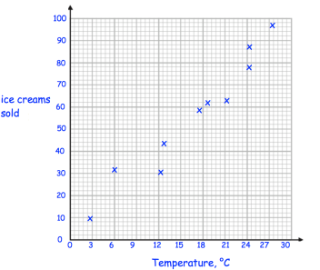  What type of correlation in shown? |   Draw a line of best fit for this data | From the graph  Estimate the number of ice creams sold on a day when the temperature is 15°C | Why should this graph not be used to estimate the temperature when 200 ice creams are sold?
2 | 6, 4, 7, 1, 3, 8, 1, 10  Work out the mode of these numbers  Work out the range of these numbers | 4, 9, 7, 10, 5  Work out the median of these numbers  Work out the mean of these numbers | 20, 30, 24, 32  Work out the median of these numbers | 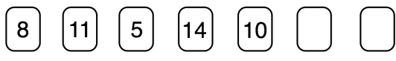  If the mode is 8 and the range is 16.  What are the two missing numbers?
3 | A manager surveys his employees to see how they travel to work.  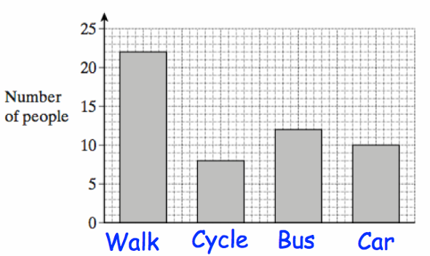  What is the least popular method of transport? …………………………………..  What is the most popular method of transport? …………………………………….. | 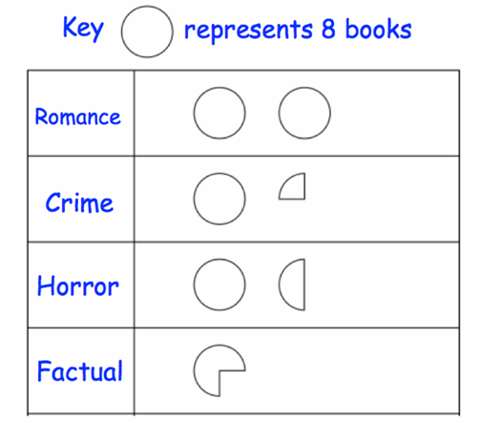  The pictogram shows the books Claire read.  How many romance books did Claire read? ………………..  How many factual books did Claire read? ………………….. | 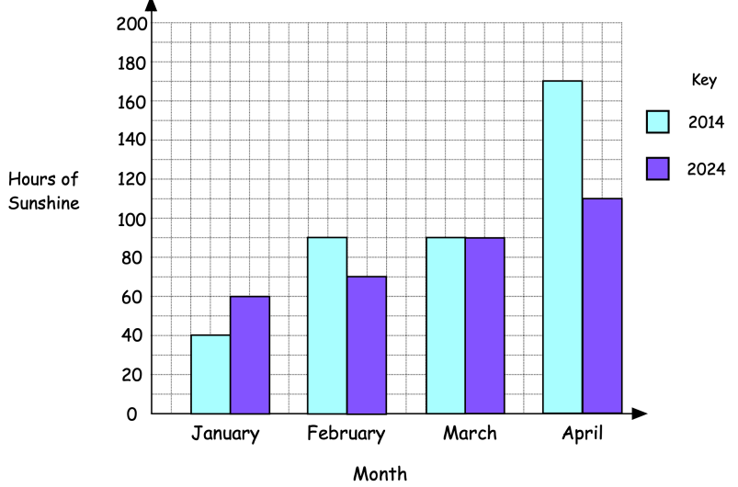  How many more hours of sunshine were there in February 2014 compared to February 2024? | 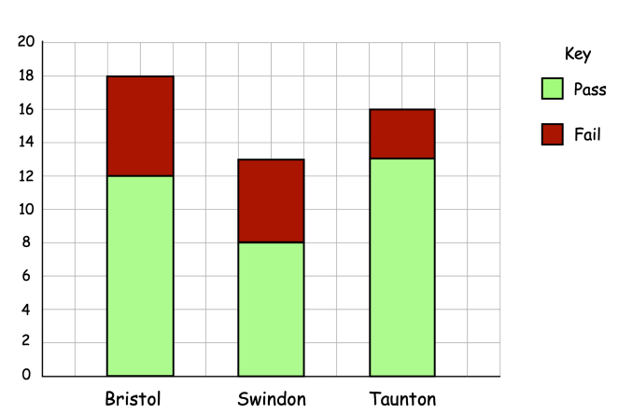  How many people failed their test in Bristol?
 | Please construct an equilateral triangle | Please bisect this line | Please bisect this angle | Please construct a perpendicular bisector which passes through the point A  A

 | RECALL
 | 425 + 699 | 748 - 487 | 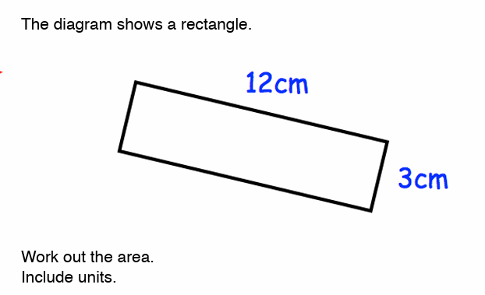  What is the area of the rectangle? Include units in your answer. | 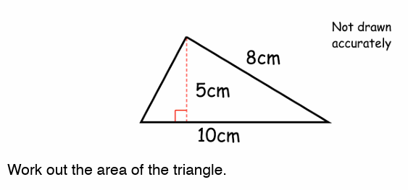  Work out the area of the triangle.
 | 17 x 21 | 453 $÷$ 5 | 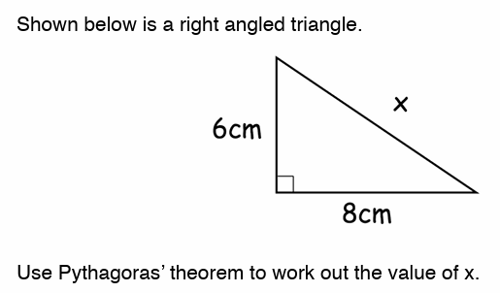  Use Pythagoras to calculate. x = | 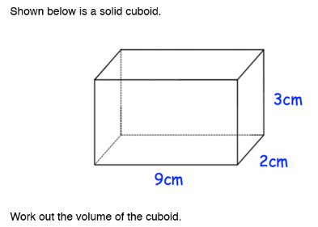  Work out the volume of the cuboid. Include units in your answer.
 | 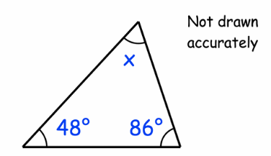  Work out the size of angle x?  x= | 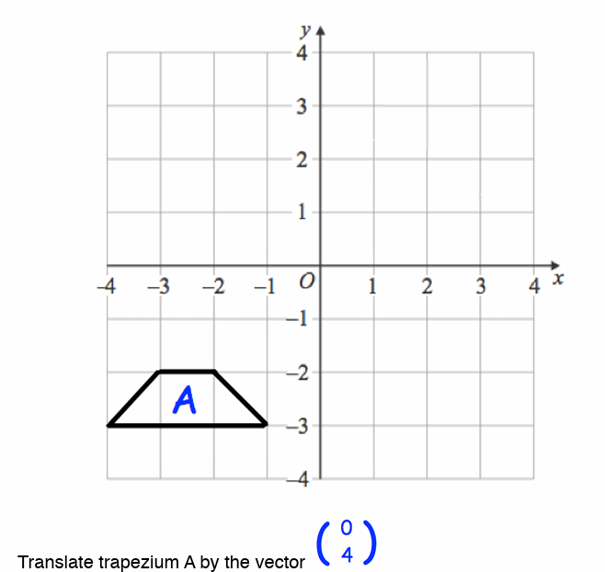  Translate the trapezium by the vector 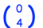 | Write down the ratio of squares to circles in its simplest form.  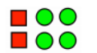 |  | Simplify the ratio 6:10
 | 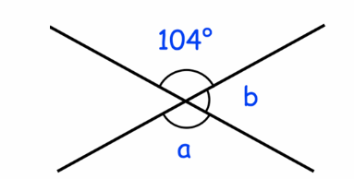  Work out the size of the angles  a = b = |  | 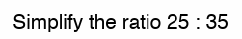 |  | 